**Exp. 25 C Program in a VM**

**Aim:**

To install a C compiler in the virtual machine created using virtual box / VM Ware Workstation / Player and execute Simple C Programs.

**Procedure:**

* Create a VM in VMware or VirtualBox.
* Start the VM, open the browser
* Install Dev C++ compiler.
* Write a C program and execute.
* Record the output

**Output:**

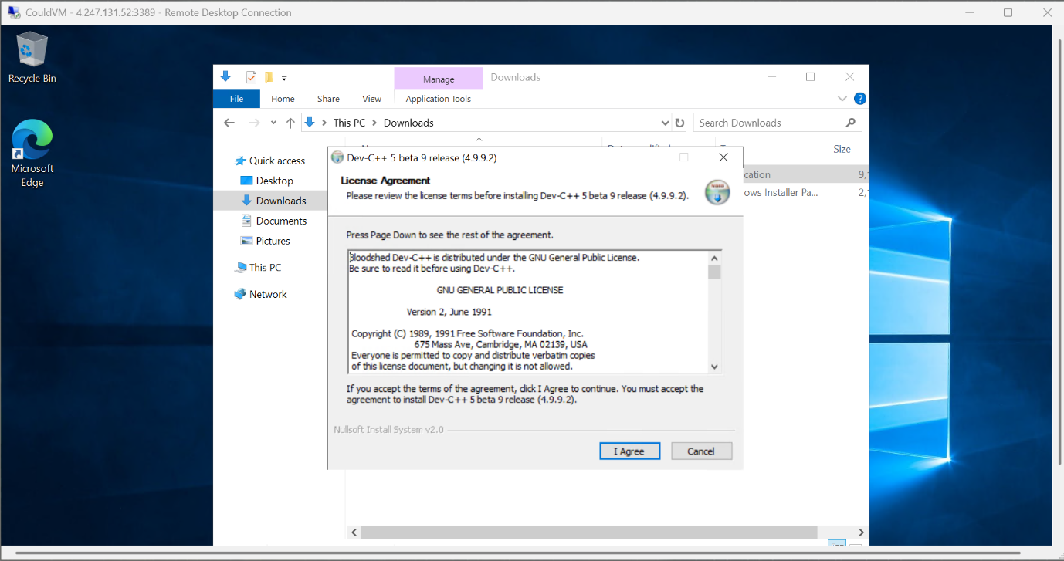

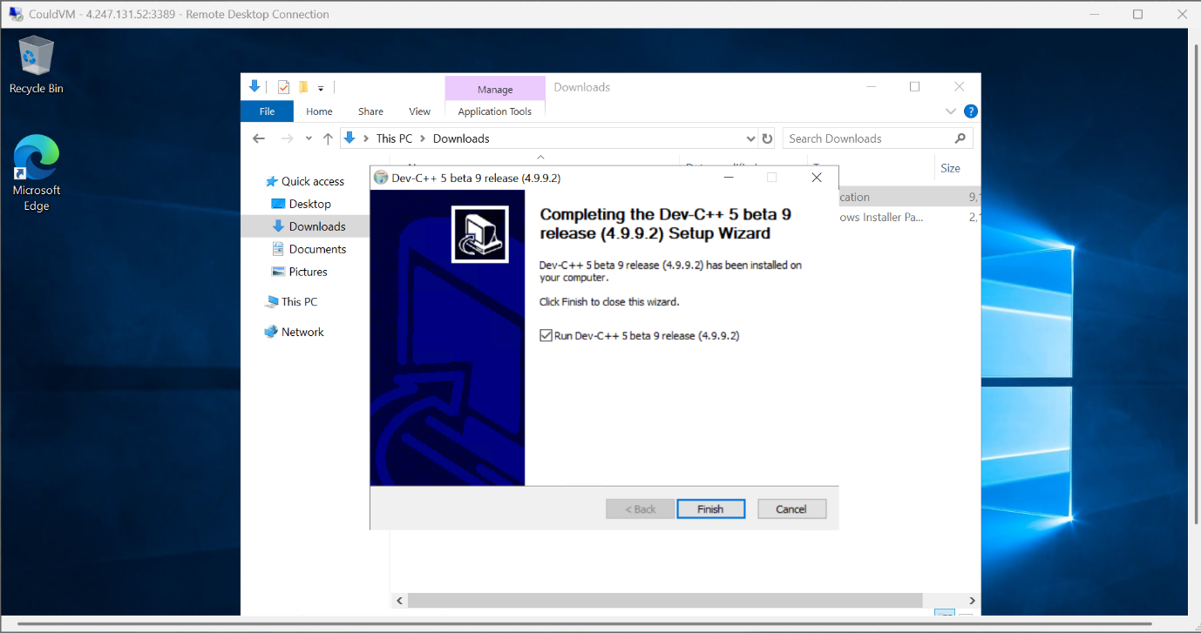

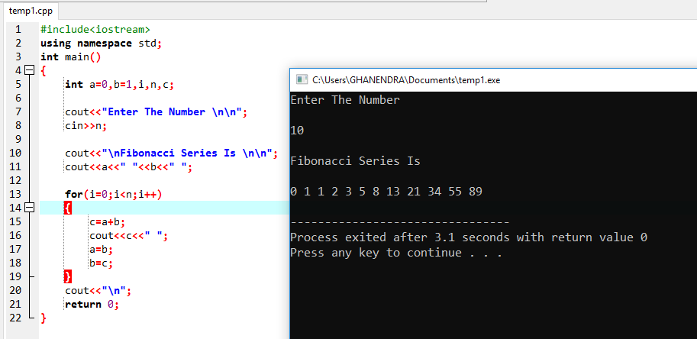

**Result:**

Thus, a C program was written and executed in a VM using Dev C++ compiler